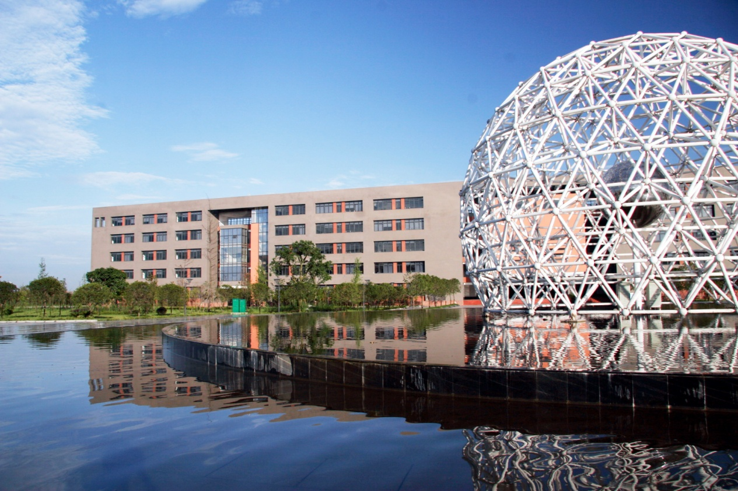
Registration Guide for International Students of Xihua University (XHU)
- Visa
Student visa (X1 and X2) to enter China should be applied by submitting required documents to the local China embassy or consulate. X1 visa is generally issued to students who plan to study in China for over 180 days and is valid for 30 days after entering China. X1 holders must begin to apply for Residence Permit at least 7 working days prior to its expiration date.
X2 visa is generally issued to students who study in China for at or less than 180 days and is only valid for one time entrance.
Please pay special attention to the visa expiration date and extend it timely if necessary. Staying with an expired visa violates the law and the violator will be fined, detained for investigation, and/or deported.

- Medical Examination
For X2 visa holders, it is recommendable to bring original medical examination documents from home hospital upon registration.
X1 visa holders have to take medical examination at Sichuan Province Entry-Exit Inspection and Quarantine Bureau (1#, North Tongzilin Road) to apply for Residence Permit.

- Transportation
It is advisable for first comers to take a taxi from Chengdu Shuangliu International Airport to Xihua University. It takes 30 minutes and tell the driver you’re going to South Gate, Xihua University, Hongguang Town （郫县红光镇西华大学南大门）. You can also contact us to arrange a car to pick you up at ￥100.
XHU is 40-minutes drive from downtown area and is connected to city center by subway Line Two. It has access to almost all kinds of transportation such as bus, subway, distance bus, and high speed train.

- Accommodation (on-campus and off-campus)
For safety reason, we recommend international students to live on campus. Please come to Room 408, Office Building to get your dormitory/apartment information. The following choices are offered:
Dormitory: two people in one room, shared bathroom, internet access, no hot water, ￥200/month
Apartment: two (or three) bedrooms, 1-2 people, shared bathroom, internet access, hot water, kitchen, air conditioner, TV, washing machine and etc., ￥1000/month (￥500/month if two students share)

- Registration
Place: Room 408, Office Building, Xihua University
Date: indicated on the admission letter
Documents required
- Ordinary passport and its photocopy
- Admission Letter and Visa Application for study in China (JW202 Form/JW201Form)
- Notarized highest diploma and transcripts. (Documents in languages other than Chinese or English must be attached with notarized translations in Chinese or English)
- 8 passport-style photos (colored, 33mm in width, 48mm in height, white background, formally dressed)
- Medical examination report for X2 visa holders (X1 visa holders will need to take medical examination in Chengdu for residence permit)
- Letter of recommendation by two professors, HSK (Chinese language) certificate and other supportive documents if you intend to apply for scholarship
Tuition fee: please visit our website http://oice.xhu.edu.cn/english/StudyatXHU/ to learn detailed information
Payment: tuition fee, insurance, rent and others can be paid at the finance office by RMB cash or bank cards issued within China.

- Residence Permit Application
X1 visa expires 30 days after entrance to China and the holder must begin to apply for residence permit at least 7 working days before the expiration date (2 weeks in advance if the medical examination is not taken). The procedure is as follows:
- Registration and payment at Room 408, Office Building
- Medical examination at 1#, North Tongzilin Road (It takes 5-7 working days to get the result)
- Get application form at Room 408, Office Building
- Apply at Chengdu Exit & Entry Administration (2#, West Renmin Road, Qingyang District)
Fee: ￥400/person for residence permit less than one year; ￥800/person for 1-3 years; and ￥1000/person for 3-5 years.

- Insurance
It is mandate for every international student (X1 holders and X2 holders) to purchase insurance upon registration. Though the students can choose out of their own preference, we recommend, for its credibility, economical price and rich experience, Comprehensive Insurance & Protection Scheme for Foreigners Staying in China offered by Ping An Annuity Insurance Company. The insurance premium is listed as follows:

Insurance Liabilities | Insurance Amount (RMB) | Age 6-69  (International Students)
 |  | Insurance Premium (RMB/half year/person) | Insurance Premium (RMB/ year/person)
Liability for Death and Accidental Disability | 100,000 | 400 | 800
Medical Treatment for Outpatient and Emergency | 20,000
Medical Treatment for Accidental Injury (with a daily limit of ￥600, the insured can enjoy 85% of reimbursement over the start limit of ￥650) | 20,000
Hospitalization Medical Treatment | 400,000

- Contacts
Tel: +86 28-87725032 (office), +86 13980593241 (Vivian Hou)
Email: oice@mail.xhu.edu.cn; 13980593241@163.com
Fax: +86 28-87725032
Address: Xihua University, Chengdu (610039), Sichuan Province, P. R. China

